**DAILY ONLINE ACTIVITIES SUMMARY**

|  |  |  |  |  |  |  |  |
| --- | --- | --- | --- | --- | --- | --- | --- |
| **Date:** | **26/05/20** | | | | **Name:** | **Namratha C** | |
| **Sem & Sec** | **8th sem, A sec** | | | | **USN:** | **4AL16CS056** | |
| **Online Test Summary** | | | | | | | |
| **Subject** | | **BDA** | | | | | |
| **Max. Marks** | | **40** | | **Score** | | **30** | |
| **Certification Course Summary** | | | | | | | |
| **Course** | **Introduction to Ethical Hacking** | | | | | | |
| **Certificate Provider** | | | **Great Learning** | **Duration** | | | **254 mins** |
| **Coding Challenges** | | | | | | | |
| **Problem Statement: 1) Python program to find sum of the array.**  **2) Python program to swap elements at given positions.** | | | | | | | |
| **Status: Completed** | | | | | | | |
| **Uploaded the report in Github** | | | | **Yes** | | | |
| **If yes Repository name** | | | | **CODES (Namrathasonu)** | | | |
| **Uploaded the report in slack** | | | | **Yes** | | | |

Online Test Details:

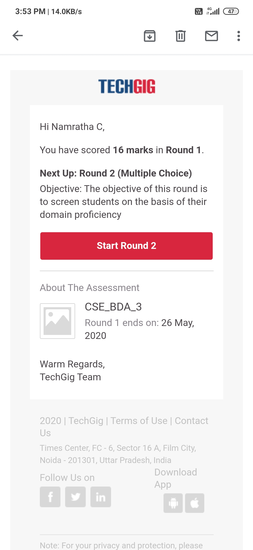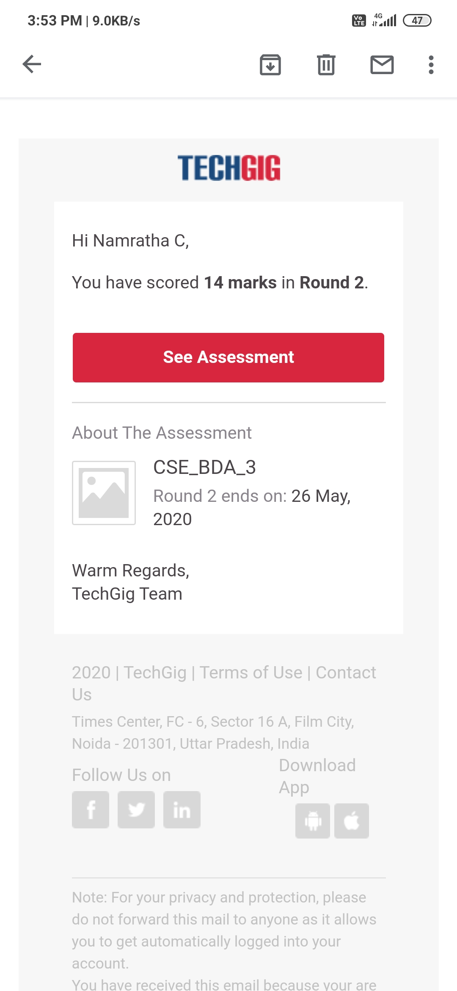

The test was on the subject Big Data Analytics on Module 4.

Certification Course Details:

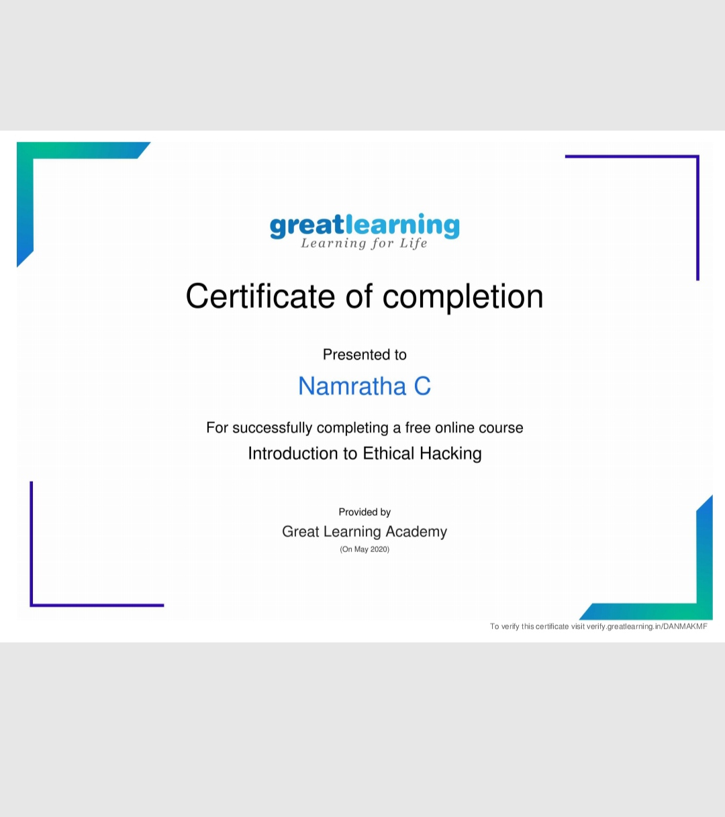

Coding Challenges Details:

1) def _sum(arr,n):

return(sum(arr))

arr=[]

arr = [12, 3, 4, 15]

n = len(arr)

ans = _sum(arr,n)

print ('Sum of the array is ', ans)

2) def swapPositions(list, pos1, pos2):

list[pos1], list[pos2] = list[pos2], list[pos1]

return list

List = [23, 65, 19, 90]

pos1, pos2 = 1, 3

print(swapPositions(List, pos1-1, pos2-1))